**CDAC Mumbai PG-DAC AUGUST 24**

**Assignment No- 2**

1)Write a program that checks if a given year is a leap year or not using both if-else and switch-case.

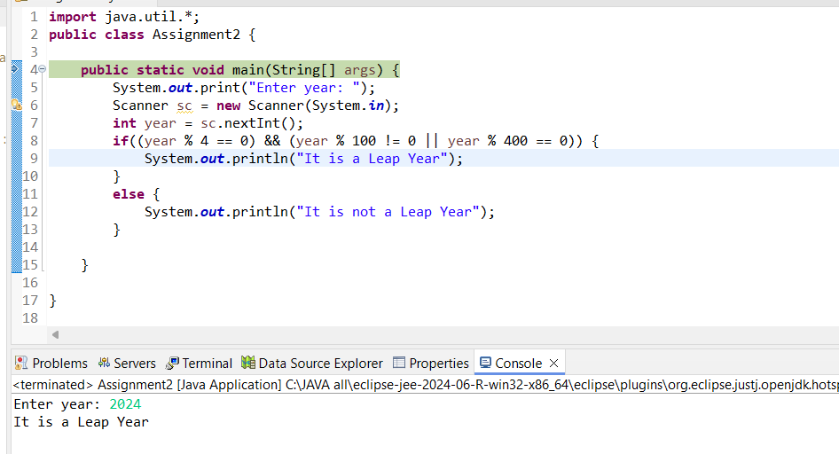

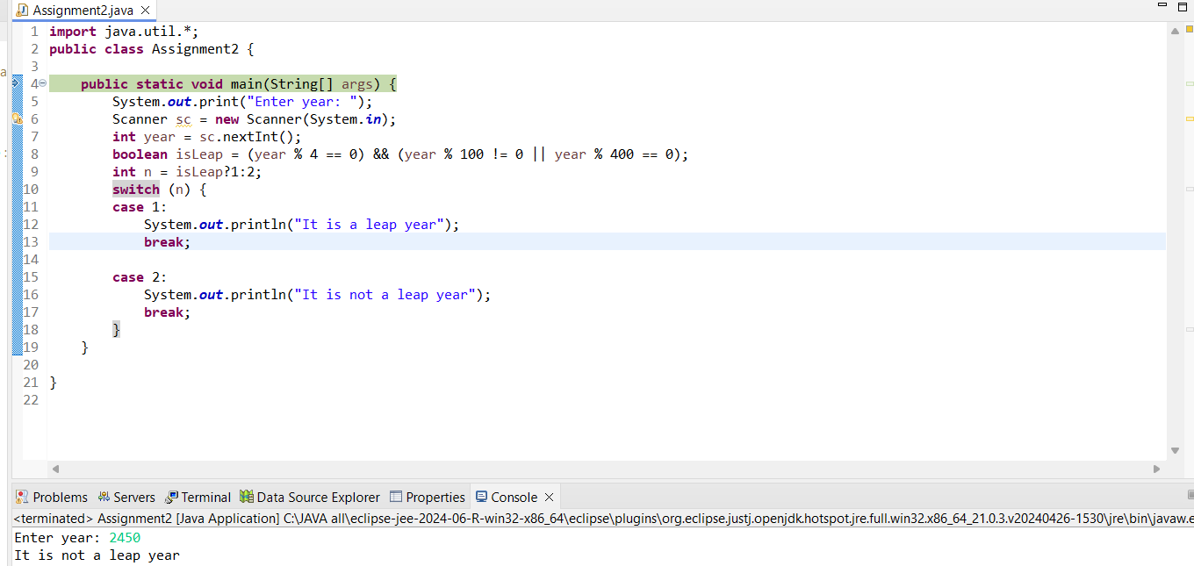

2)Implement a program that calculates the Body Mass Index (BMI) based on height and weight input using if-else to classify the BMI int categories (underweight, normal weight, overweight,etc).

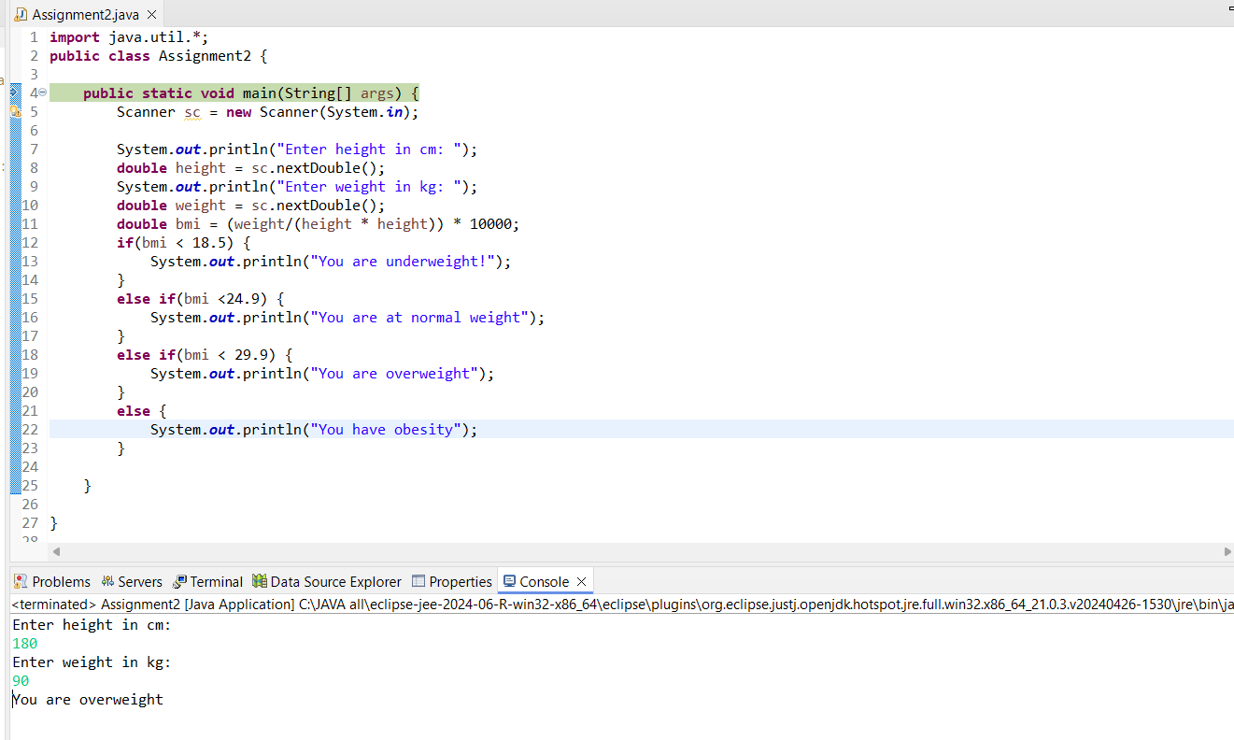

3)Write a program that checks if a person is eligible to vote based on their age.

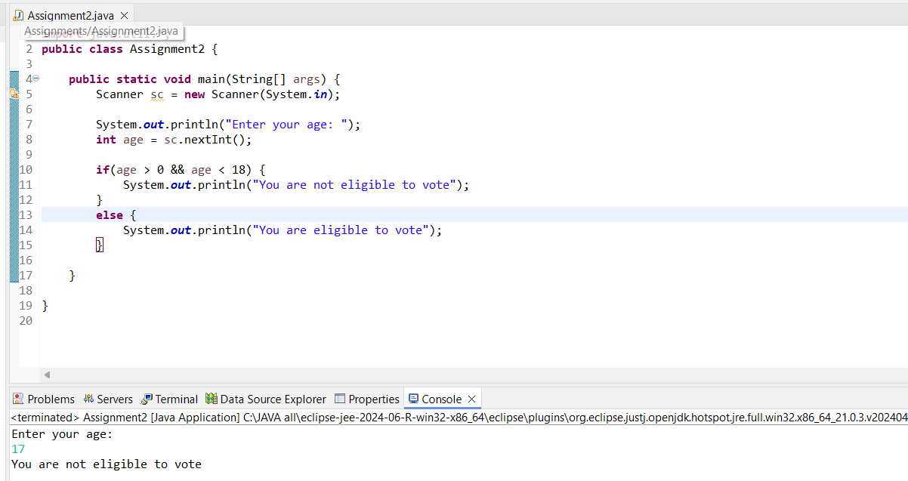

4)Write a program that takes a month (1-12) and prints the corresponding season (Winter, Spring, Summer, Autumn) using a switch case

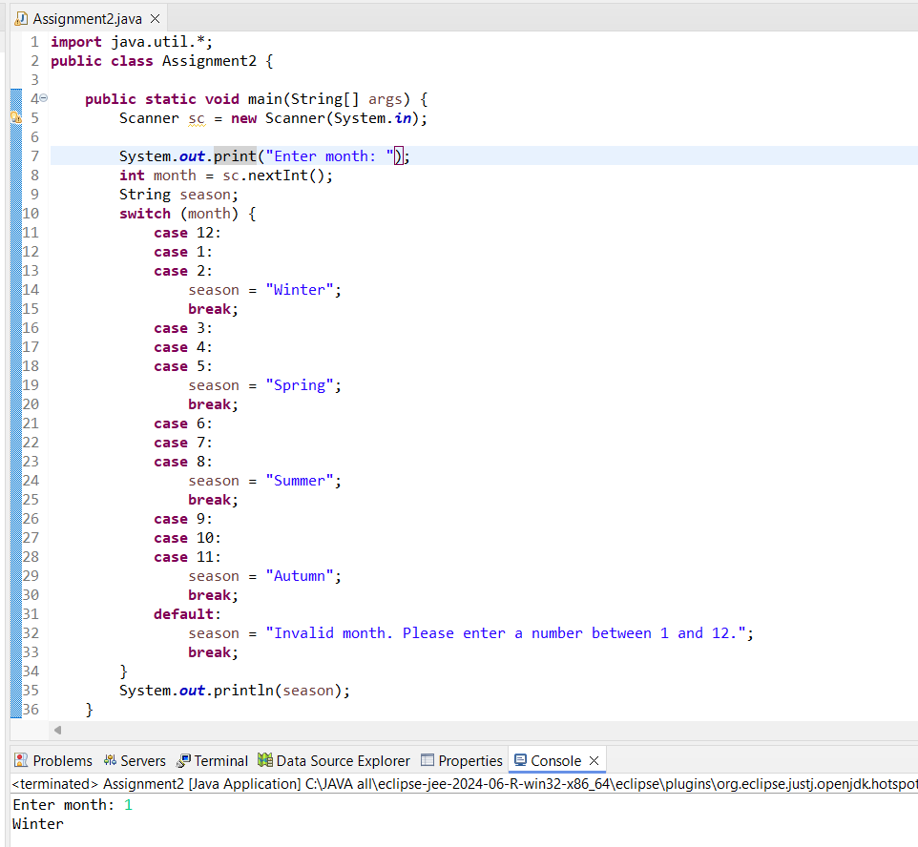

5)Write a program that allows the user to select a shape (Circle, Square, Rectangle, Triangle) and then calculates the area based on user-provided dimensions using a switch case.

**import** java.util.Scanner;

**public** **class** Assignment2 {

**public** **static** **void** main(String[] args) {

Scanner scanner = **new** Scanner(System.***in***);

System.***out***.println("Select a shape to calculate its area:");

System.***out***.println("1. Circle");

System.***out***.println("2. Square");

System.***out***.println("3. Rectangle");

System.***out***.println("4. Triangle");

System.***out***.print("Enter your choice (1-4): ");

**int** choice = scanner.nextInt();

**double** area;

**switch** (choice) {

**case** 1:

System.***out***.print("Enter the radius of the circle: ");

**double** radius = scanner.nextDouble();

area = 3.141 * radius * radius;

System.***out***.print("The area of the circle is: " + area);

**break**;

**case** 2:

System.***out***.print("Enter the side length of the square: ");

**double** side = scanner.nextDouble();

area = side * side;

System.***out***.print("The area of the square is: " + area);

**break**;

**case** 3:

System.***out***.print("Enter the width of the rectangle: ");

**double** width = scanner.nextDouble();

System.***out***.print("Enter the height of the rectangle: ");

**double** height = scanner.nextDouble();

area = width * height;

System.***out***.print("The area of the rectangle is: " + area);

**break**;

**case** 4:

System.***out***.print("Enter the base of the triangle: ");

**double** base = scanner.nextDouble();

System.***out***.print("Enter the height of the triangle: ");

**double** heightTriangle = scanner.nextDouble();

area = 0.5 * base * heightTriangle;

System.***out***.print("The area of the triangle is: " + area);

**break**;

**default**:

System.***out***.println("Invalid choice. Please select a number between 1 and 4.");

**break**;

}

scanner.close();

}

}

